2019
Kiva Technology User’s Manual

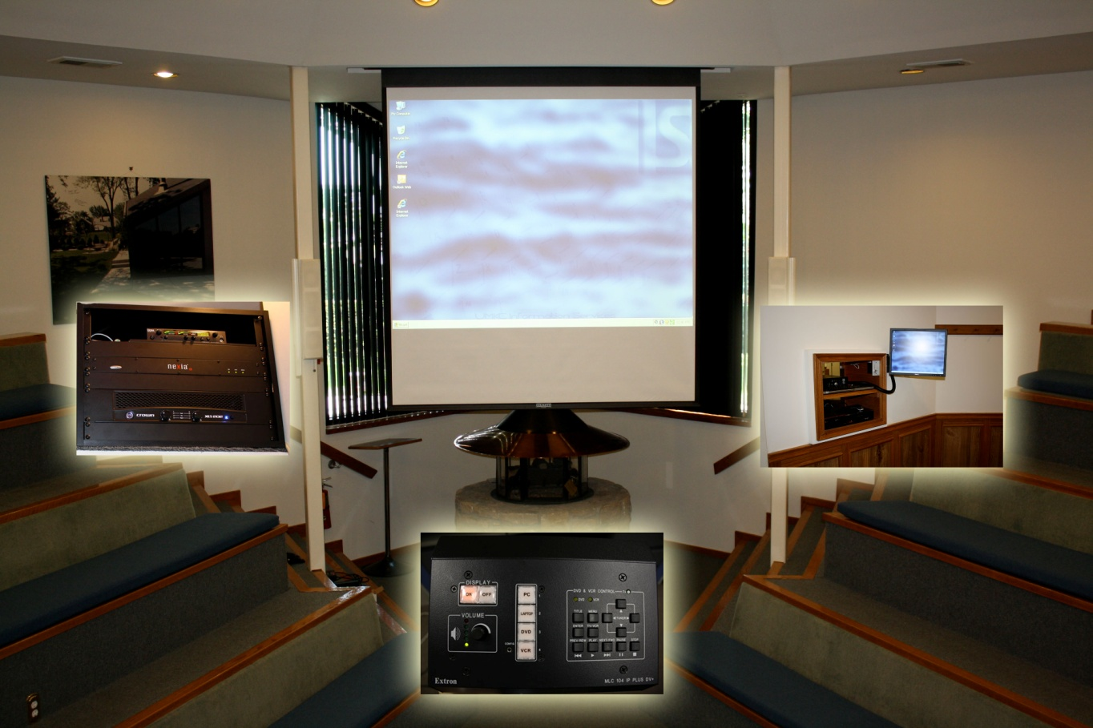
Support Contact Avenues
Call Center: (816) 235-2000 Monday – Friday: 7:00 am - 5:00 pm
ILE Support E-Mail: ILESupport@UMKC.EDU
PC Log-in Credentials:Username: umkc-ileuser
Password: Lecture$

INDEX Page
- To Use the System Computer (PC) ............................................................ 3 - 4
- To Use a Laptop Computer ........................................................................ 5 - 6
- To Play a DVD .............................................................................................. 7 - 8
- To Play a VCR tape or Watch Cable TV...................................................... 9 - 10
- To plug a different external device into the system, such as a Camcorder or Video Game Console................................................... 11 - 12
- External Microphone Connection............................................................... 13
7. Advanced Audio Controls……………………………………………………… 14 - 15
8. Common Problems ..................................................................................... 15 – 16
9. Screen Mirroring ………………………………………………………………... 17

To Use the System Computer (PC):
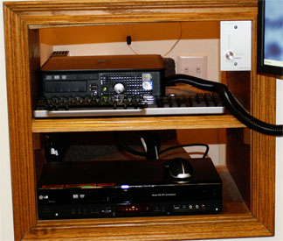
1: Use the Wireless Mouse and Keyboard to ensure the System Computer is not off or in sleep mode. The System Computer, Wireless Keyboard and Mouse is located on the wooden shelves located next to the Kiva room entrance (behind door if door is open).
Mouse
Keyboard

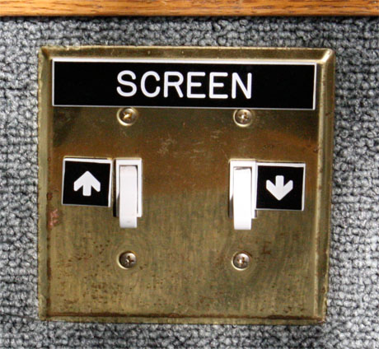
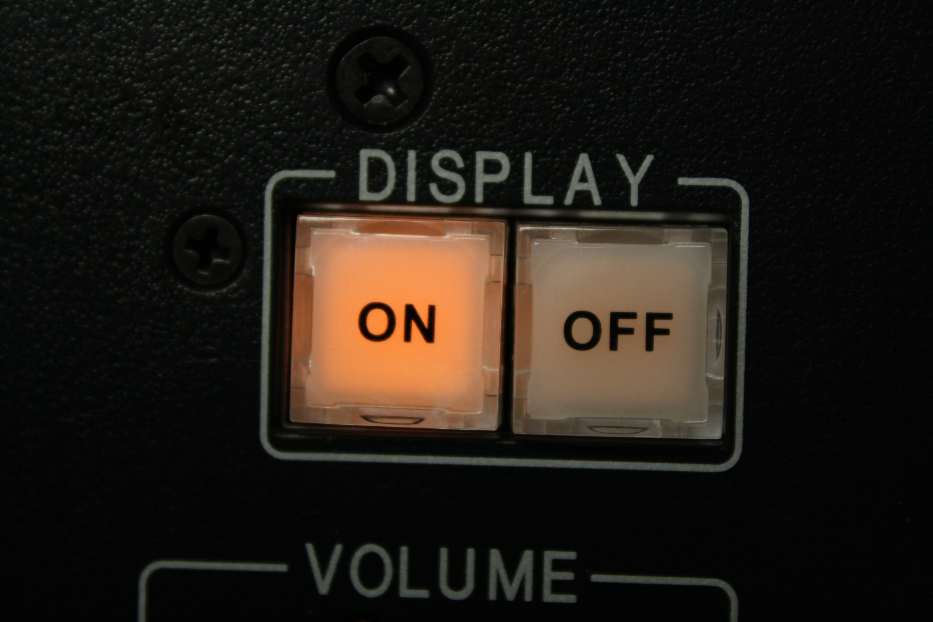
2: Push the display “ON” button on the Control Panel to turn on the Video Projector, and then lower the screen to an acceptable viewing position. The Control Panel and Screen UP/DOWN Panel are located on the steps at the front of the room (next to the fireplace).
Screen Control Panel
Control Panel

3: Push the “PC” button on the Control Panel to select the System Computer as the video source you wish to view through the projector.
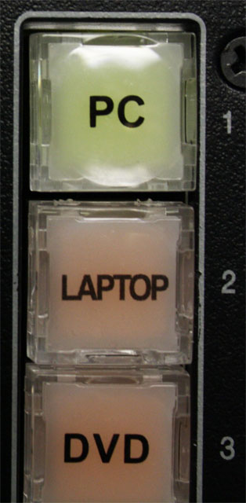
PC Button

To Use the System Computer (PC): cont’d
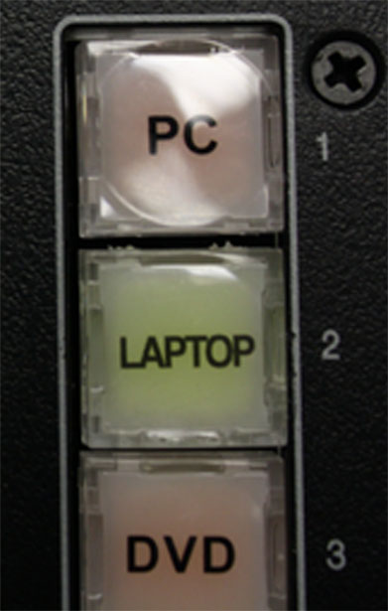
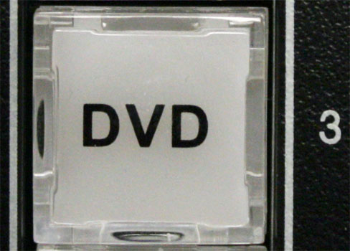
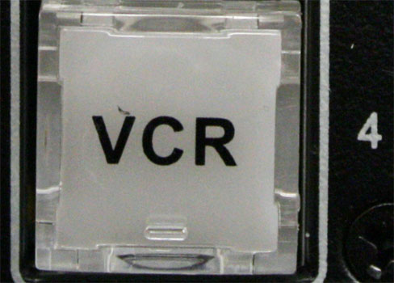
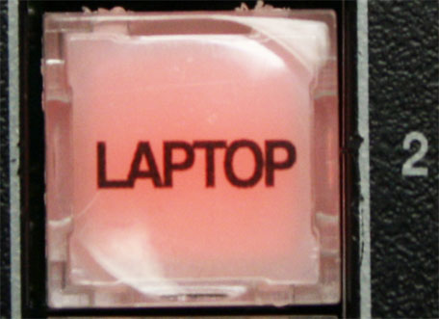
4: You may select other video sources as desired by pressing the appropriate button on the Control Panel.
Select LAPTOP

Select DVD
Select VCR
2nd press selects AUX Panel input.
In.

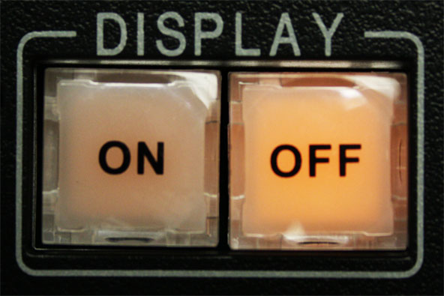
5: When done be sure to push the display “OFF” button on the Control Panel to shut off the Video Projector (you will still hear a hum or whirring sound as the projector cools down).
Control Panel

To Use a Laptop Computer:
1: Use the provided cable (located in the Control Room when not in use) to connect the VGA and headphone connections on the Laptop Computer to the identical connections on the Aux Panel located on the steps at the front of the room (next to the fireplace).
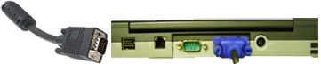
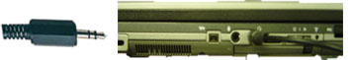
VGA Cable
Audio Cable

2: Make sure that the Laptop is on and not in sleep mode by moving your mouse using the touchpad on the Laptop Computer.
3: Push the display “ON” button on the Control Panel to turn on the Video Projector, and then lower the screen to an acceptable viewing position. The Control Panel and Screen UP/DOWN Panel are located on the steps at the front of the room (next to the fireplace).
Screen Control Panel
Control Panel

4: Push the “Laptop” button on the Control Panel to select Laptop as the video source you wish to view through the projector. You will see an image on the screen saying “RGB 1”.
Laptop Button

5 We recommend that the Laptop volume be set to ¾, and the preferred screen resolution set at 1024 X 768. Mac Laptops may need a video adapter- these vary with Mac model and are not part of Diastole’s A/V equipment.
To Use a Laptop Computer: cont’d
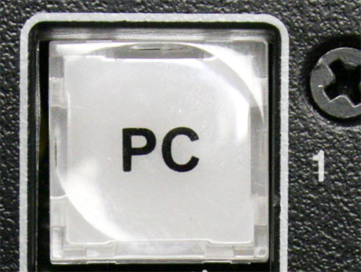
6: You may select other video sources as desired by pressing the appropriate button on the Control Panel.
Select PC
Select DVD
Select VCR
2nd press selects AUX Panel input.
In.

7: When done be sure to push the display “OFF” button on the Control Panel to shut off the Video Projector, and press “PC” to place the system in standby mode.
PC Button
Control Panel

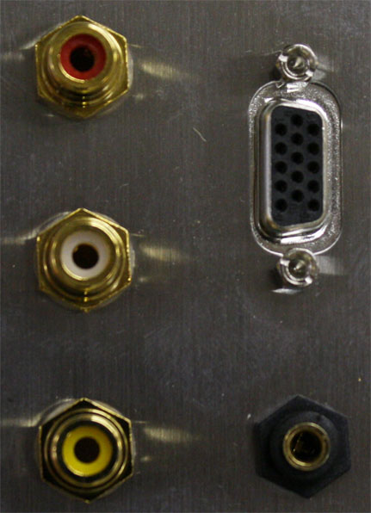
9: Be sure to disconnect the VGA/audio cable from the Laptop Computer and the Aux. Panel.
VGA Cable
AUX Panel
Audio Cable

To Play a DVD:
1: Ensure that the DVD/VCR player power is on. The DVD/VCR player is located on the wooden shelves located next to the Kiva room entrance (behind door is door is open).
2: Place your DVD into the DVD/VCR player tray.
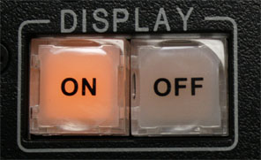
3: Push the display “ON” button on the Control Panel to turn on the Video Projector, and then lower the screen to an acceptable viewing position. The Control Panel and Screen UP/DOWN Panel are located on the steps at the front of the room (next to the fireplace).
Control Panel
Screen Control Panel

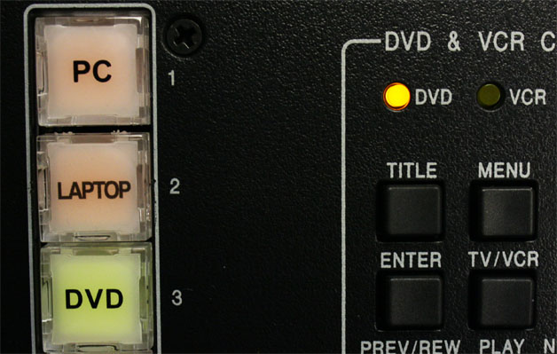
4: Push the “DVD” button on the Control Panel to select the DVD/VCR player as the video source you wish to view through the projector.
DVD LED – Designates the DVD was selected as a source.
DVD Button

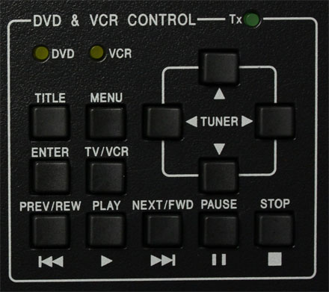
5: The buttons on the right side of the Control Panel can be used to navigate through the DVD/VCR player screen menu.
DVD & VCR Control Panel

To Play a DVD: cont’d
6: To switch from DVD you may select other video sources as desired by pressing the appropriate button on the Control Panel.
Select PC
Select LAPTOP

Select VCR
2nd press selects AUX Panel input.
In.

7: When done be sure to push the display “OFF” button on the Control Panel to shut off the Video Projector, and press “PC” to place the system in standby mode.
PC Button
Control Panel

8: Do not forget to remove your DVD media from the DVD/VCR player when done.

To Play a VCR tape or Watch Cable TV:
1: Ensure that the DVD/VCR player power is on. The DVD/VCR player is located on the wooden shelves located next to the Kiva room entrance (behind door if door is open).
2: If you wish to view a VCR tape, insert the tape into the DVD/VCR player at this time. If you wish to watch Cable TV make sure no VCR tape or DVD has been left in the DVD/VCR player by a previous user of the system.
3: Push the display “ON” button on the Control Panel to turn on the Video Projector, and then lower the screen to an acceptable viewing position. The Control Panel and Screen UP/DOWN Panel are located on the steps at the front of the room (next to the fireplace).
Control Panel
Screen Control Panel

4: Push the “VCR” button on the Control Panel to select the DVD/VCR player as the video source you wish to view through the projector.
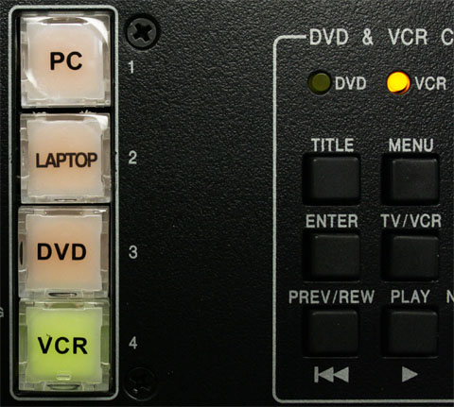
VCR LED – Designates the VCR was selected as a source.
VCR Button

To Play a VCR tape or Watch Cable TV: cont’d
5: The buttons on the right side of the Control Panel can be used to control the VCR player functions. The UP and DOWN arrow buttons change the channels when watching Cable Television.
DVD & VCR Control Panel
UP Arrow Button
DOWN Arrow Button

6: : To switch from VCR or Cable TV you may select other video sources as desired by pressing the appropriate button on the Control Panel.
Select PC
Select LAPTOP

2nd press selects AUX Panel input.
In.

Select DVD

7: When done be sure to push the display “OFF” button on the Control Panel to shut off the Video Projector, and press “PC” to place the system in standby mode.
PC Button
Control Panel

8: Do not forget to remove your VCR tape from the DVD/VCR player when done.

To plug a different external device into the system, such as a Camcorder or Video Game Console:
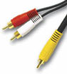
1: Use a Component Cable to connect device to the identical connections on the Aux Panel located on the steps at the front of the room (next to the fireplace). Component connections are usually color coded Yellow (Video), White (Stereo Left), and Red (Stereo Right). This cable is usually provided with devices such as Camcorders and Gaming consoles.
RCA Cable
AUX Panel
WHITE Stereo Left
RED Stereo Right
YELLOW Video

2: Make sure that the device is turned on and if necessary set to send a Video/Audio signal to an external device.
3: Push the display “ON” button on the Control Panel to turn on the Video Projector, and then lower the screen to an acceptable viewing position. The Control Panel and Screen UP/DOWN Panel are located on the steps at the front of the room (next to the fireplace).
Control Panel
Screen Control Panel

To plug a different external device into the system, such as a Camcorder or Video Game Console: cont’d
4: Push the “Laptop” button on the Control Panel to toggle between the VGA/Line In connections and the RCA component (Yellow, White, and Red) connections on the Aux. Panel. After one or two pushes of the Laptop button you will see your device displaying through the Video Projector. The image on the projector will say “Video Input”.
1st press selects VGA/Line In.

2nd press selects to AUX Panel input.
In.

5: To switch from external devices you may select other video sources as desired by pressing the appropriate button on the Control Panel.
Select PC
Select DVD
Select VCR

6: When done be sure to push the display “OFF” button on the control panel to shut off the Video Projector, and press “PC” to place the system in standby mode.
PC Button
Control Panel

External Microphone Connection:
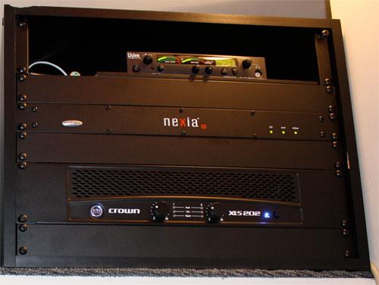
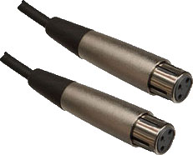
To attach an External Microphone to the system there are two XLR (3 prong) connectors located on the top shelf of the Black Rack in the control room. Most professional grade microphones/wireless microphones have these connections. Some microphones have an On/Off switch located on them. Make sure this switch is on when testing or using the microphone.
Black Rack
XLR 3 Prong Connectors

Advanced Volume Controls:
The Kiva room has two Master Volume Controllers. One is located in the wooden shelves near the entrance, and the other located inside the control room. Both Master Volume Controllers are capable of controlling overall room volume, but can also control specific devices in the room independently.
Turning the volume control knob turns the selected devices volume up and down. Level is indicated by the horizontal row of LED’s on the face of the controller.
Pressing the volume control knob selects the device that will be controlled. The selected device is indicated by the vertical column of LED’s on the face of the controller.
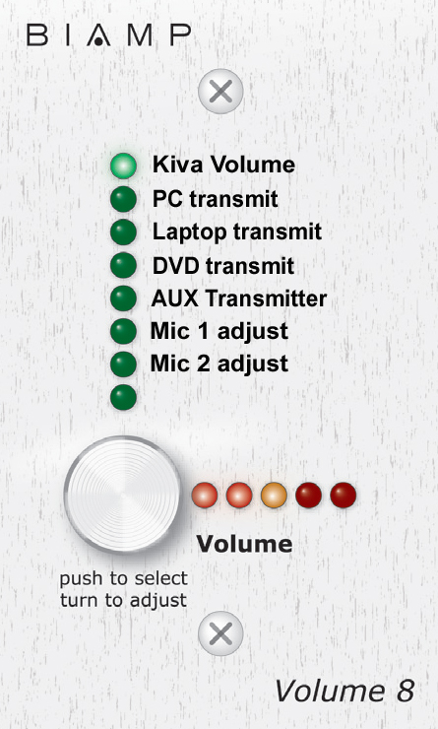

Select Device

Adjust Volume

1: Kiva Volume controls all audio levels in the room.
2: PC transmit controls the volume of the System Computer.
3: Laptop transmit controls the volume of a Laptop computer.
4: DVD transmit controls the volume of the DVD/VCR Player.
5: Aux Transmitter controls the volume of the Auxiliary Wireless Speakers.
6: Mic 1 adjust controls the volume of Microphone Input (XLR) 1.
7: Mic 2 adjust controls the volume of Microphone Input (XLR) 2.
Advanced Volume Controls: cont’d
We recommend always returning the Master Volume Controller to the Kiva Volume setting when done adjusting the volume level of other devices.
Common Problems:
The System Computer is awake and I can see it on the monitor at the back of the room, however the Video Projector is displaying a message saying “Video Source Not Found” or a blue screen.
The last person to use the equipment may have been using a Laptop computer. Since there is currently no Laptop connected to the system it is displaying the “Source Not Found” error message. Push the PC button to display the System Computer video.
This situation can also arise if you are trying to view VCR or DVD content. Push the appropriate button on the control panel to ensure the Video Projector is receiving a video signal from the desired source.
I have pushed the Laptop button on the control panel, but my laptop video is still not being displayed by the Video Projector.
Many Laptops will automatically sense when an external display unit (such as a Video Projector) has been attached to the Laptop. If it does not, you may see a message displayed by the Video Projector that says “No Video Source Found”.
If this occurs look for the Function Key (FN) in the lower left corner of the Laptops keyboard. The lettering on this key is usually in a different color (often blue). Press and hold this key while tapping the appropriate Function Key located along the top of the Laptop keyboard ((usually depicted with a symbol of a monitor, or occasionally VGA/CRT, in the same color as the (FN) key)). By pressing and holding the (FN) key while tapping the appropriate Function Key you will cycle through 2 0r 3 different video modes, one of which should switch your Laptop video to display through the Video Projector.
I can see my Laptop being shown through the projector, but I have little or no volume.
Make sure that the Laptop itself is not muted, and that the volume on the Laptop is set to ¾.
I can hear the Video Projector running after I turn it off.
You may hear the fan in the Video projector running for a short time after turning the Video Projector off. This is a normal cool down phase that protects the projectors bulb from excessive heat. The cool down phase may last a minute or two.

Common Problems: cont’d
I tried to turn the Video Projector back on immediately after I turned it off and it did not respond.
The Video projector will not respond to commands during the cool down phase.
I was watching Cable Television. When I finished I turned off the projector but I can still hear the TV over the room speakers.
Press any other source on the Control Panel (preferably the PC button) to switch the system away from the TV audio.
The wireless keyboard/mouse is not responding.
The wireless keyboard/mouse may have lost connection. Press the connect button on the bottom of the keyboard or mouse as well as on the USB dongle inserted in a USB port on the back of the System Computer. Rebooting the computer should also reestablish the connection.
Be aware that the wireless keyboard/mouse runs on 2 AA rechargeable batteries which may need to be replaced on occasion.
The System Computer is on and awake, however I have a black screen on the monitor at the back of the room.
Press the “Input” button on the front of the Monitor. If additional steps are needed, see “Screen Mirroring” on p17.
I have connected a microphone/wireless microphone to the system using the XLR connections in the control room, but I have low volume or feedback.
Use the Advanced Volume Controller to adjust the volume level of the microphone(s) up if the volume is too low, or down if you hear feedback. Adjust the microphone volume until it is at a comfortable level compared to any other audio that may be played in the room. Remember to set the Advanced Volume Controller back to the Kiva Volume setting when done.

Screen Mirroring:
Kiva ILE Users should see the monitor desktop mirrored on the drop-down screen.
Turn on projector using remote.
To select the proper input, press “PC” on the remote or the box underneath the drop-down screen.
Press any key on keyboard or click the mouse to make sure computer is awake.

If image is only visible on one source (either the monitor or the drop-down screen):
Type Win+P on the keyboard to check screen mirroring settings.
Be sure the “duplicate”display setting is selected to view on monitor AND drop-down screen

If image is not visible on the monitor:
Press the input button on the front of the monitor and use arrows to select “Auto Select”
If no signal found, check all HDMI connections in the closet behind the Kiva

If everything is connected properly, and the “duplicate” display setting is selected:
Call University Information Services Technology Support Center at 816.235.2000

